1. **PURPOSE:**

To lay down the procedure for Management of Open Lab Software.

1. **SCOPE:**

This procedure is applicable for Ezchrome Elite Open Lab software.

1. **RESPONSIBILITY:**
   1. Analyst-QC is responsible to follow this SOP.
   2. Head-QC/Designee is responsible for ensuring implementation of this SOP.
   3. Head-QA/Designee is responsible for monitoring overall compliance of this SOP.
2. **DEFINITION:** Nil
3. **PROCEDURE:**
   1. All instruments / equipments that are controlled by software and connected with computer systems shall be accessed through user account and password.
   2. Such instruments / equipments shall be accessed by the user with user ID and password provided for them.
   3. The Manager/in charge shall be responsible to create the new project every month.
   4. The following **USER types (4 Levels)** are available:
      1. Analyst
      2. Reviewer
      3. Asst. Manager / Manager / Sr. Manager
      4. Administrator
   5. The following **ROLES (6 roles)** are available in Open Lab software:
      1. Everything
      2. System administrator
      3. Instrument administrator
      4. Project administrator
      5. Instrument user
      6. EZChrome analyst
   6. Roles screen shots are mention below:

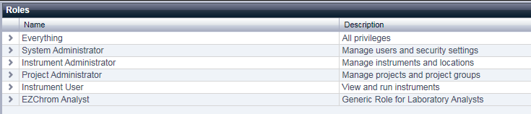

* 1. User types and allotted Role Membership as given below:

|  |  |
| --- | --- |
| **User Type** | **Allotted Role Membership** |
| Analyst | Instrument User  EZ Chrom Analyst |
| Reviewer | Project Administrator  Instrument User  EZ Chrom Analyst |
| Asst. Manager / Manager / Sr. Manager | System Administrator  Instrument Administrator  Project Administrator  Instrument User  EZ Chrom Analyst |
| Administrator | Everything |

* 1. Allotted Role Membership given below:
     1. **Analyst**

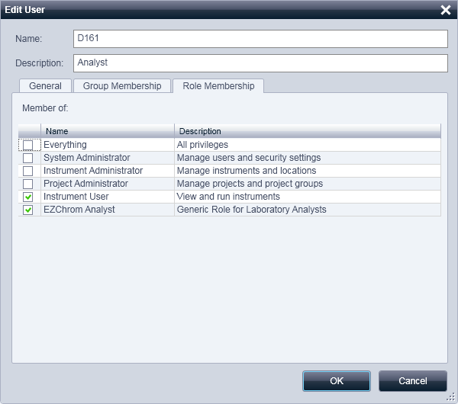

* + 1. **Reviewer**

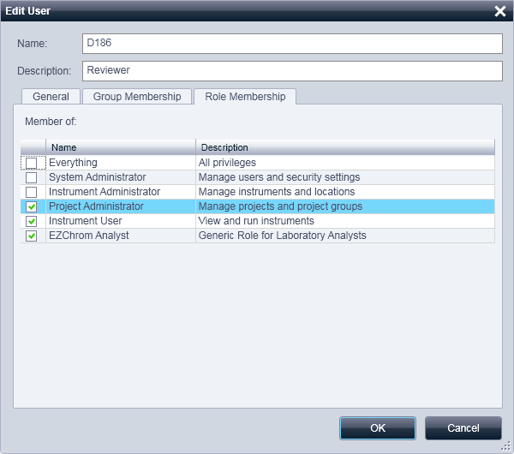

* + 1. **Asst. Manager / Manager / Sr. Manager**

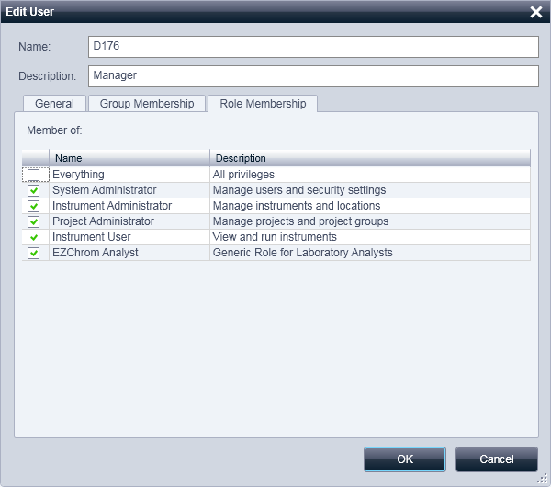

* + 1. **Administrator**

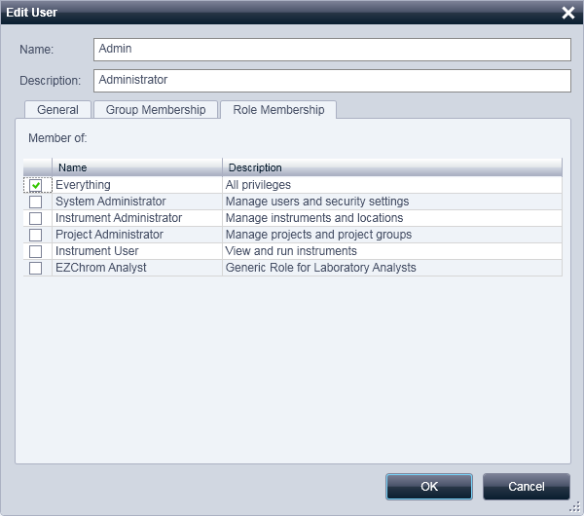

* 1. Users privileges as given below:

| ***Privilege*** | ***Analyst*** | ***Reviewer*** | ***Manager*** | ***Admin*** |
| --- | --- | --- | --- | --- |
| View instrument or location | ✓ | ✓ | ✓ | ✓ |
| Manage instrument or location | ✓ | ✓ | ✓ | ✓ |
| Manage instrument or location access | ✓ | ✓ | ✓ | ✓ |
| Run instrument | ✓ | ✓ | ✓ | ✓ |
| Service instrument | ✓ | ✓ | ✓ | ✓ |
| View project or project group | ✓ | ✓ | ✓ | ✓ |
| Manage project or project group | ✓ | ✓ | ✓ | ✓ |
| Edit content of project | ✓ | ✓ | ✓ | ✓ |
| Manage project or project group access | ✓ | ✓ | ✓ | ✓ |
| Manage printers | ✓ | ✓ | ✓ | ✓ |
| Edit activity log properties | × | × | × | ✓ |
| Create administrative reports | ✓ | ✓ | ✓ | ✓ |
| Manage system components | ✓ | ✓ | ✓ | ✓ |
| Manage security | ✓ | ✓ | ✓ | ✓ |
| Manage instrument controllers | ✓ | ✓ |  | ✓ |
| Unlock and locked UI | × | × | × | ✓ |
| E- Signature Sign Data Files | × | × | × | ✓ |
| E- Signature Revoke | × | × | × | ✓ |
| Save method | ✓ | ✓ | ✓ | ✓ |
| Edit method properties | ✓ | ✓ | ✓ | ✓ |
| Open method | ✓ | ✓ | ✓ | ✓ |
| Instrument Setup | × | ✓ | ✓ | ✓ |
| Integration Events | ✓ | ✓ | ✓ | ✓ |
| Peaks Groups | ✓ | ✓ | ✓ | ✓ |
| Advanced Parameters | ✓ | ✓ | ✓ | ✓ |
| Custom Reports | ✓ | ✓ | ✓ | ✓ |
| System Suitability | ✓ | ✓ | ✓ | ✓ |
| Review Calibration | ✓ | ✓ | ✓ | ✓ |
| Calibrate | ✓ | ✓ | ✓ | ✓ |
| Edit Running Method | ✓ | ✓ | ✓ | ✓ |
| Update Master Method | ✓ | ✓ | ✓ | ✓ |
| Save Data | ✓ | ✓ | ✓ | ✓ |
| Open Data | ✓ | ✓ | ✓ | ✓ |
| Edit Properties | ✓ | ✓ | ✓ | ✓ |
| Manual Integration Fixes | ✓ | ✓ | ✓ | ✓ |
| Open Sequence | ✓ | ✓ | ✓ | ✓ |
| Sequence Save | ✓ | ✓ | ✓ | ✓ |
| Process Sequence | ✓ | ✓ | ✓ | ✓ |
| Sequence Properties | ✓ | ✓ | ✓ | ✓ |
| Edit Any Running Sequence | ✓ | ✓ | ✓ | ✓ |
| Edit Own Running Sequence | ✓ | ✓ | ✓ | ✓ |
| Open Sample Prep | ✓ | ✓ | ✓ | ✓ |
| Save Sample Prep | ✓ | ✓ | ✓ | ✓ |
| Edit Sample Prep Properties | ✓ | ✓ | ✓ | ✓ |
| Edit Running Sample Prep | ✓ | ✓ | ✓ | ✓ |
| Update Master Sample Prep | ✓ | ✓ | ✓ | ✓ |
| Preview Run | ✓ | ✓ | ✓ | ✓ |
| Single Run | ✓ | ✓ | ✓ | ✓ |
| Sequence Run | ✓ | ✓ | ✓ | ✓ |
| Print Setup | ✓ | ✓ | ✓ | ✓ |
| Manual Control (idle only) | ✓ | ✓ | ✓ | ✓ |
| Manual Control | ✓ | ✓ | ✓ | ✓ |
| Monitor All Data | ✓ | ✓ | ✓ | ✓ |
| Abort Any Run | × | × | × | ✓ |
| Add Standard Report Template | ✓ | ✓ | ✓ | ✓ |
| Open Advanced/Intelligent Report | ✓ | ✓ | ✓ | ✓ |
| Save Advanced/ Intelligent Report | ✓ | ✓ | ✓ | ✓ |
| Lock/ unlock report template items | ✓ | ✓ | ✓ | ✓ |

* + 1. **Everything privileges:**

All privileges

* + 1. **System administrator privileges:**

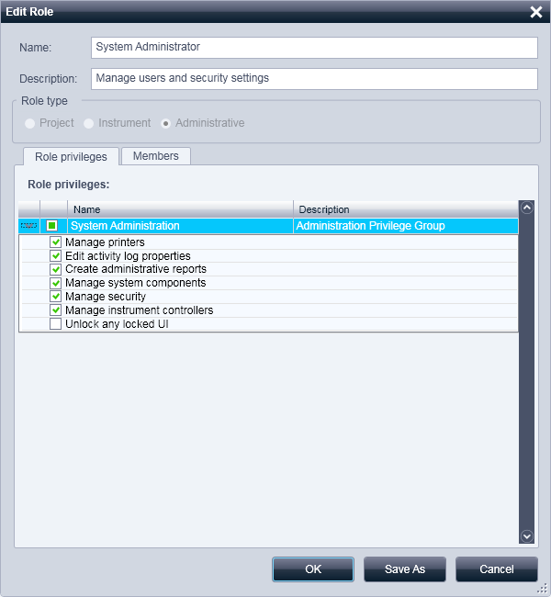

* + 1. **Instrument administrator privileges:**

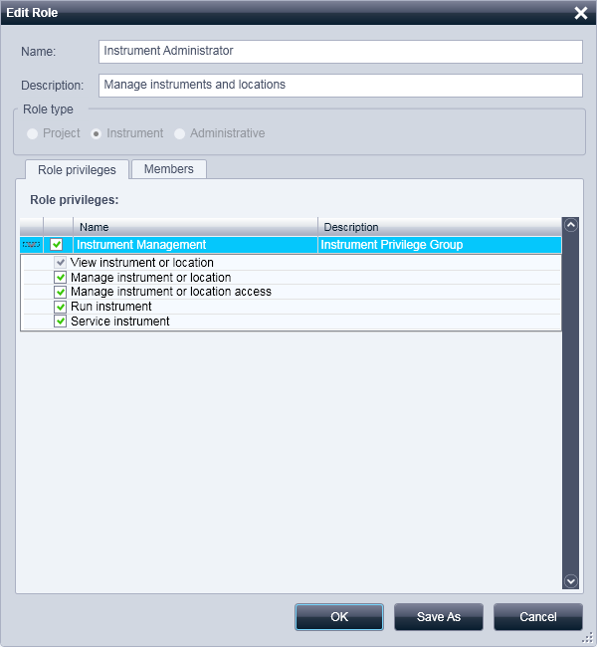

* + 1. **Project Administrator privileges:**

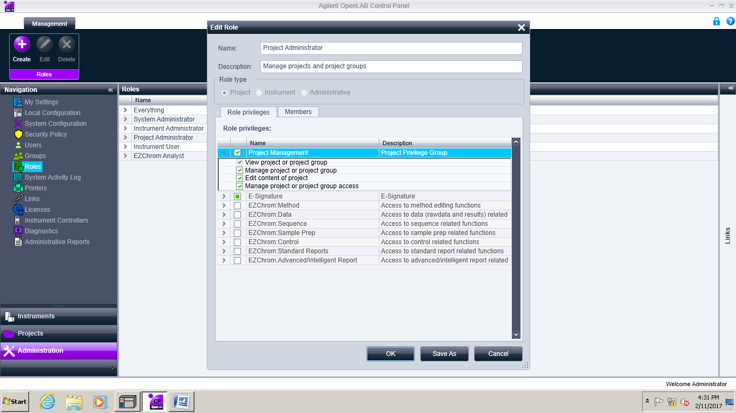

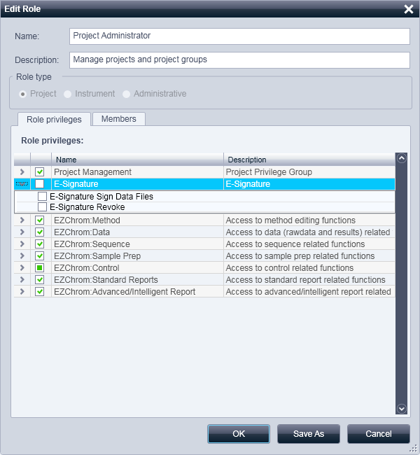

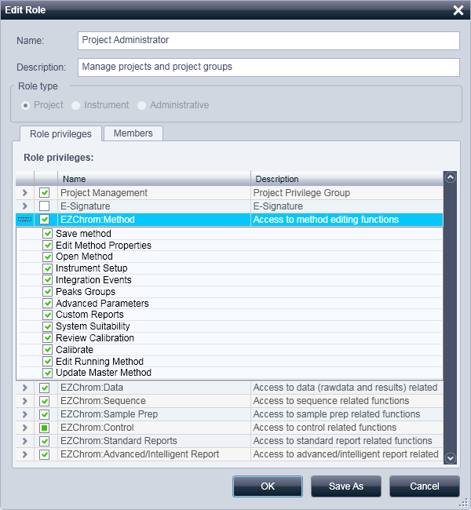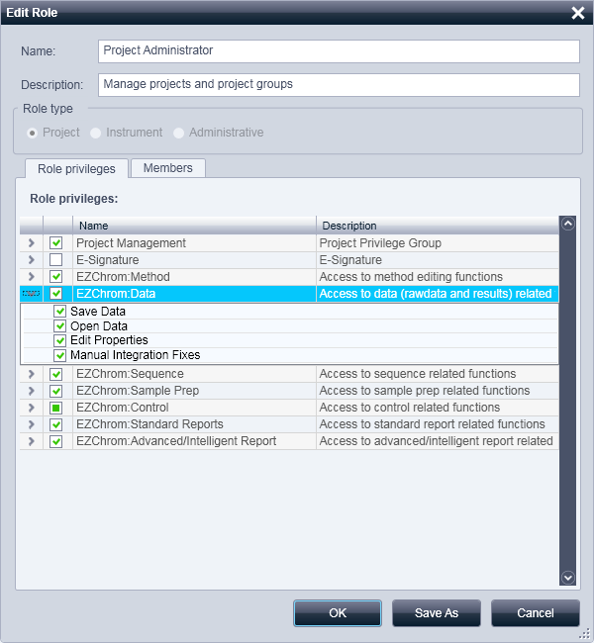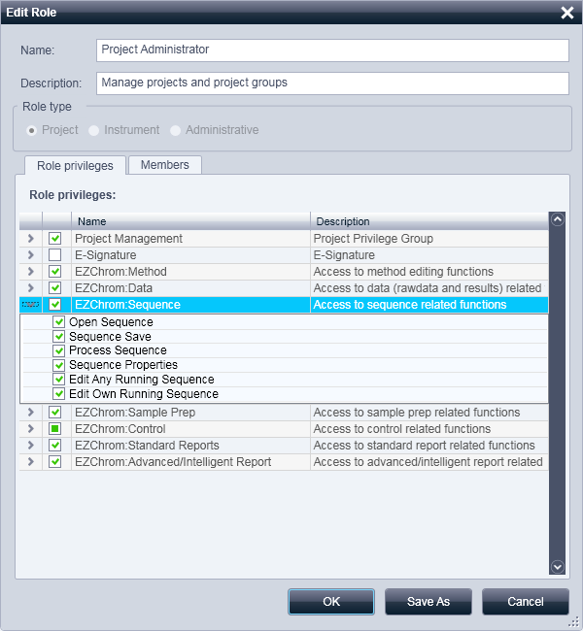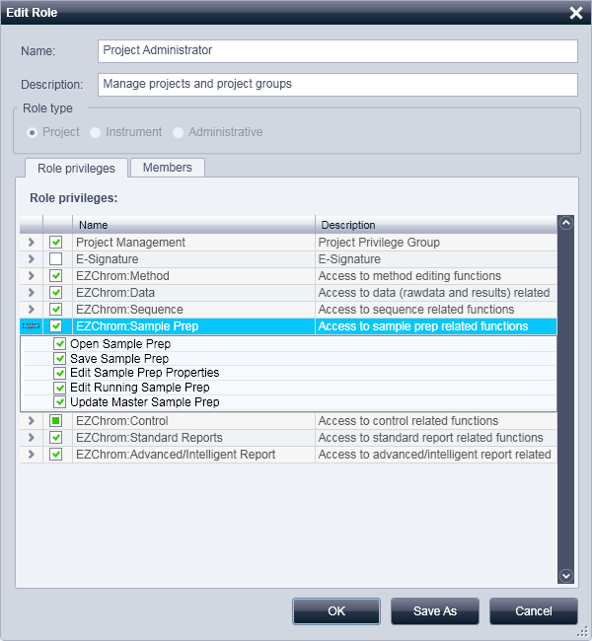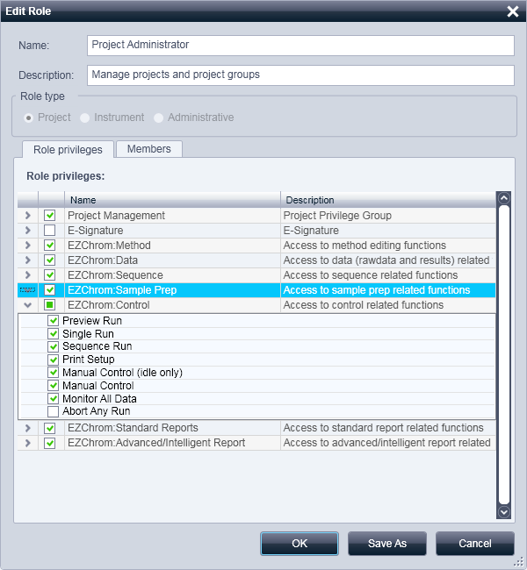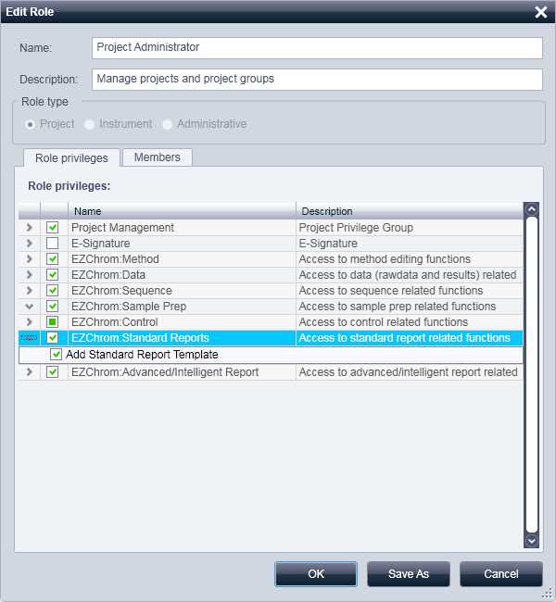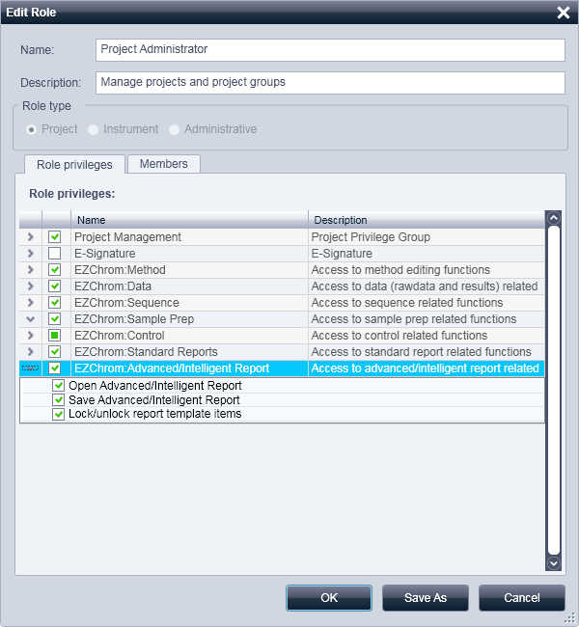

* + 1. **Instrument User privileges:**

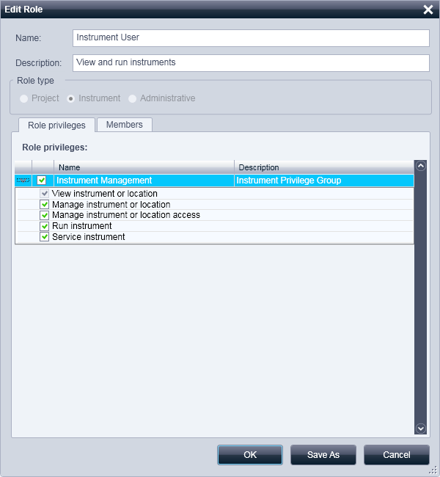

* + 1. **EZChrom Analyst**

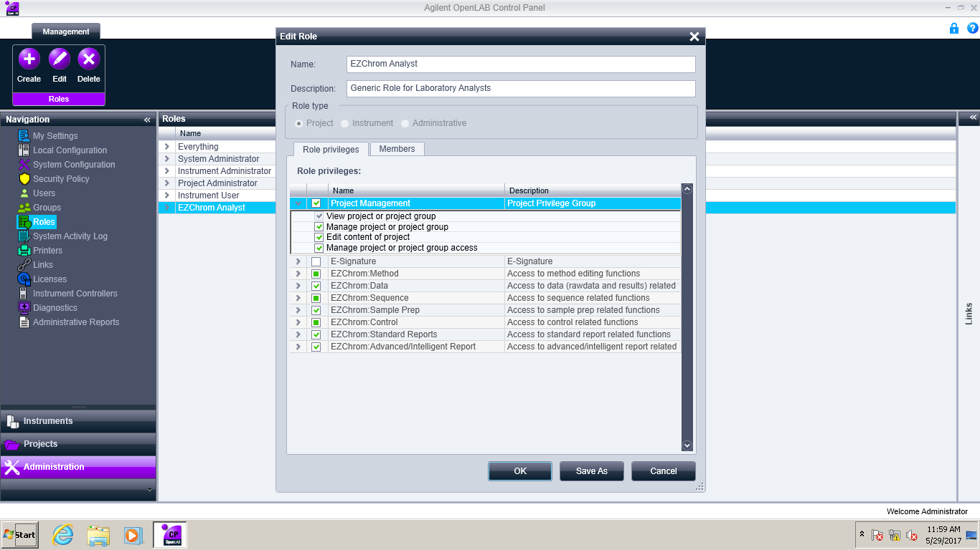

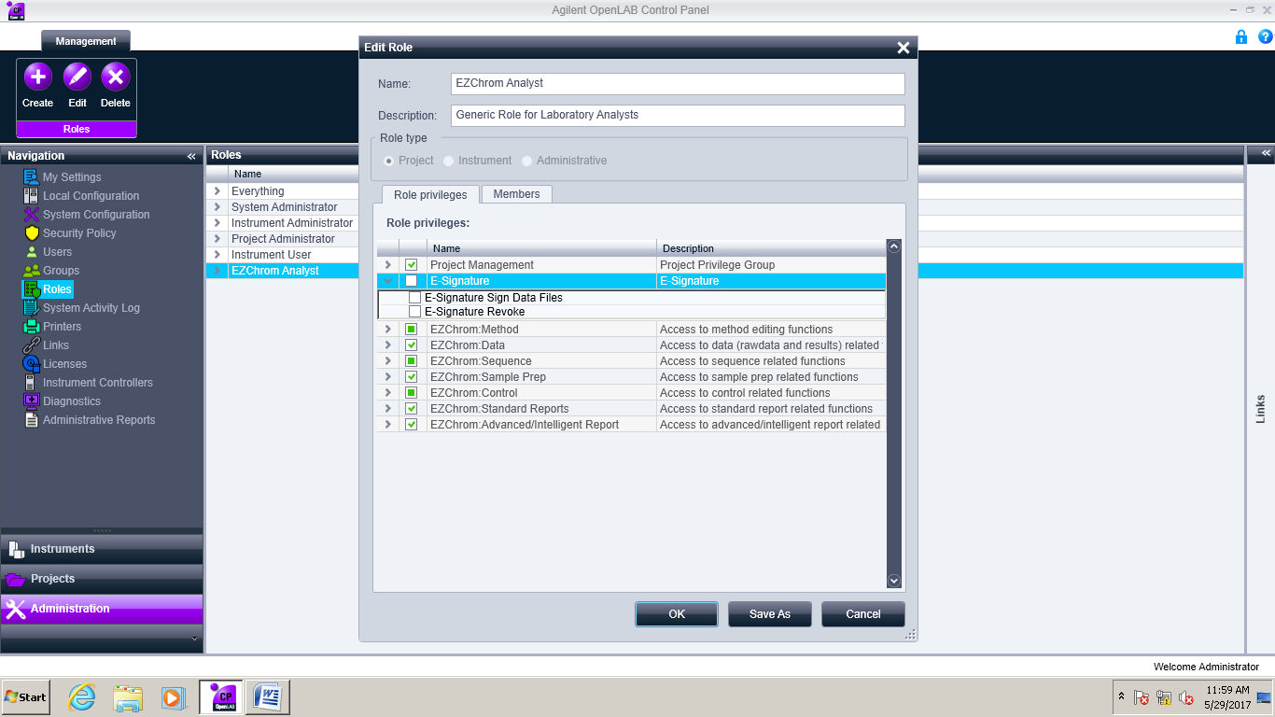

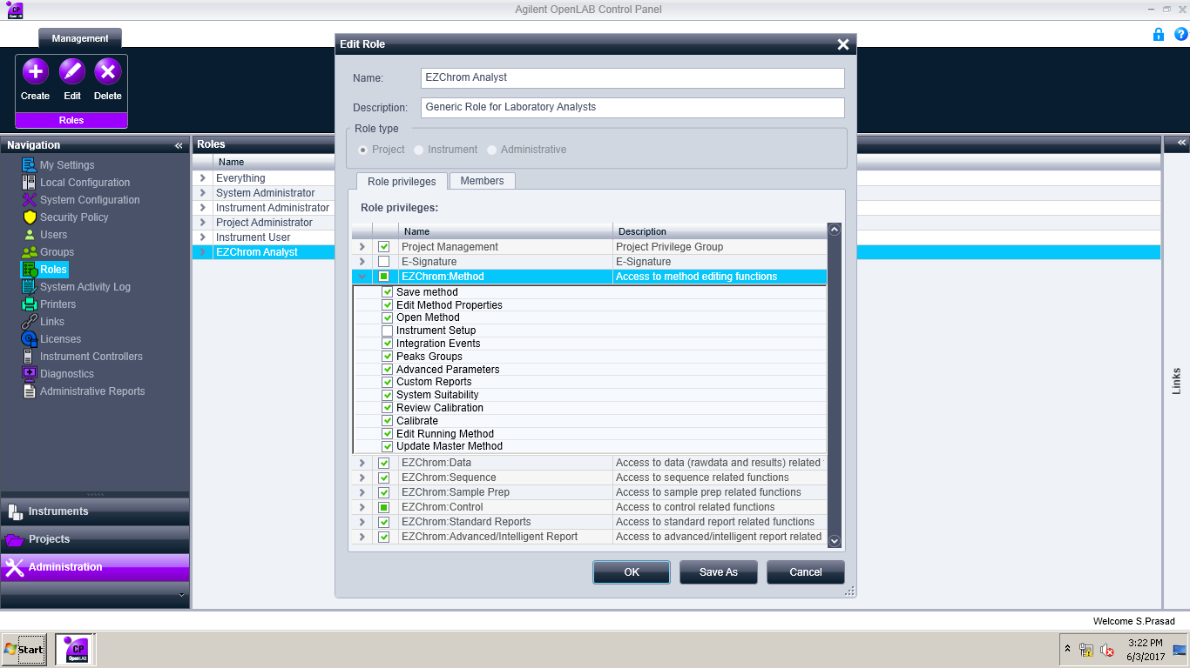

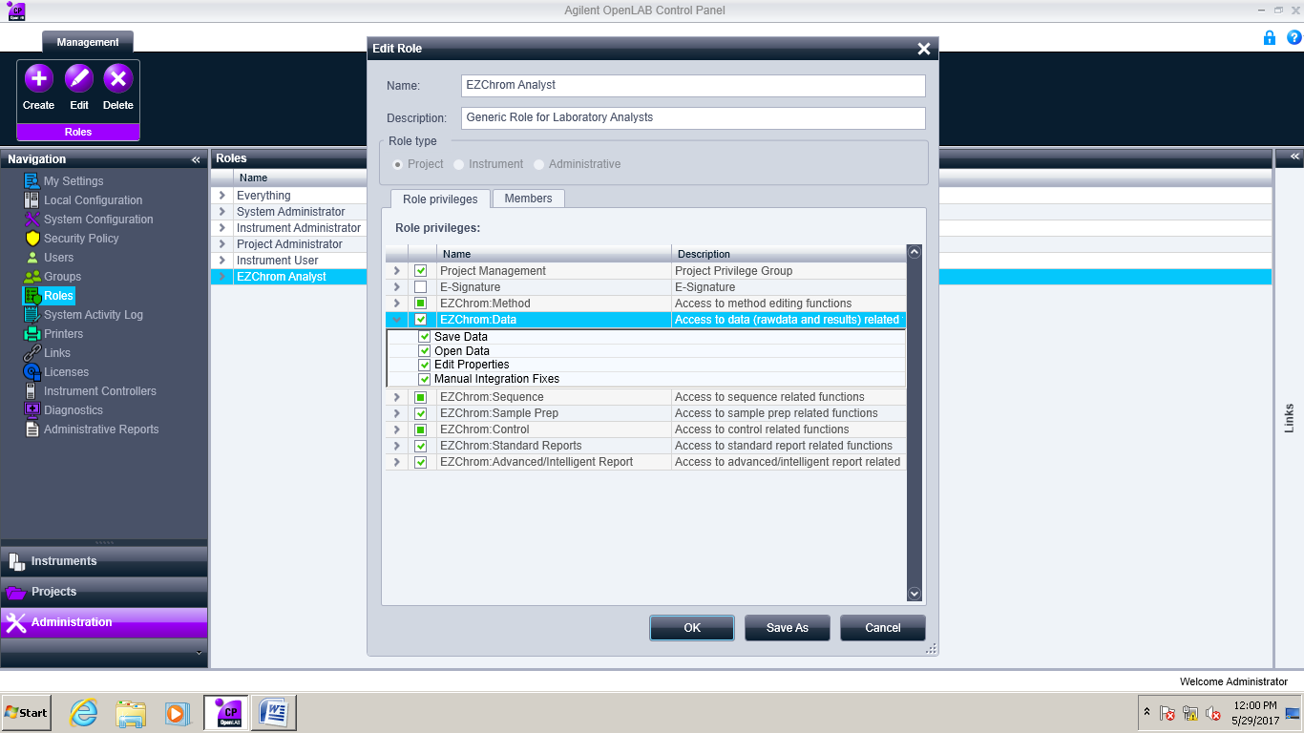

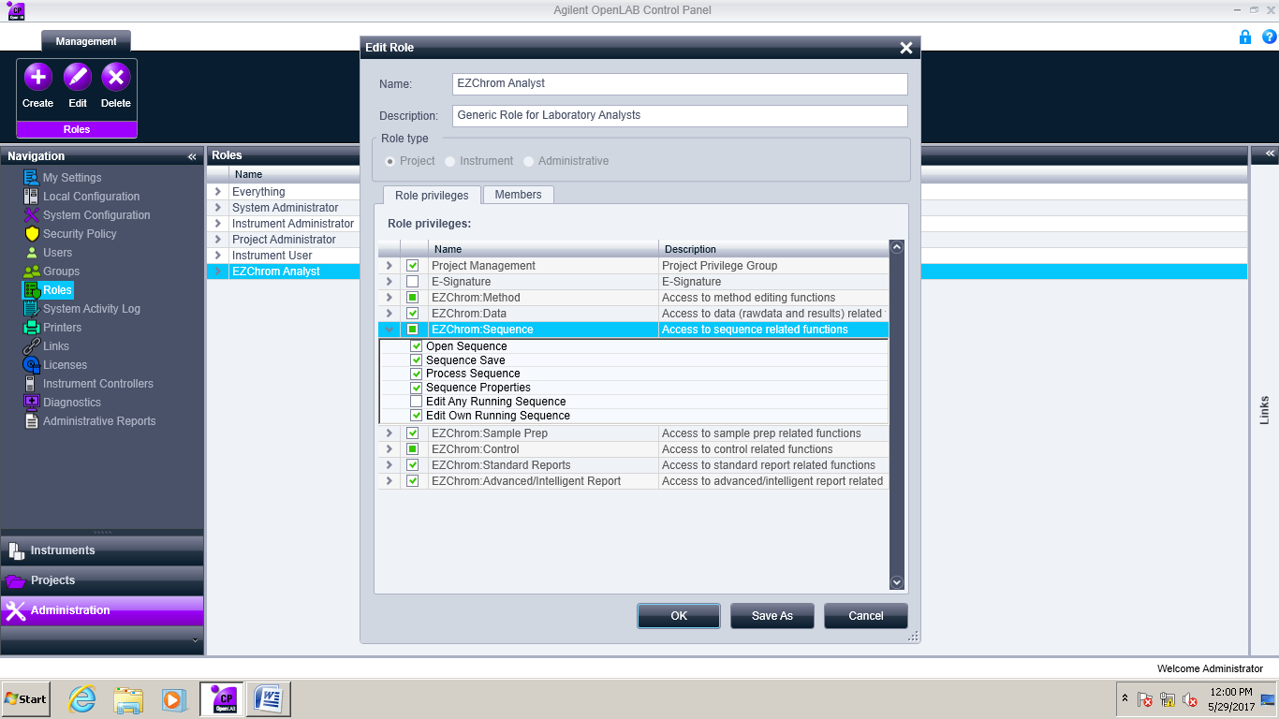

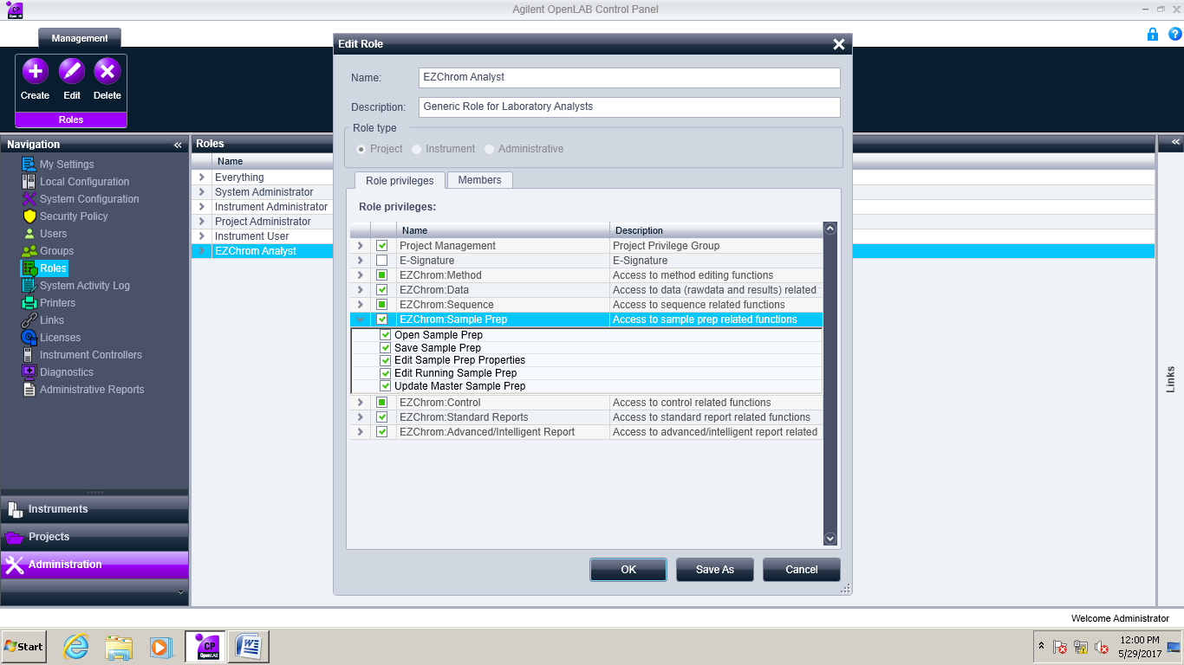

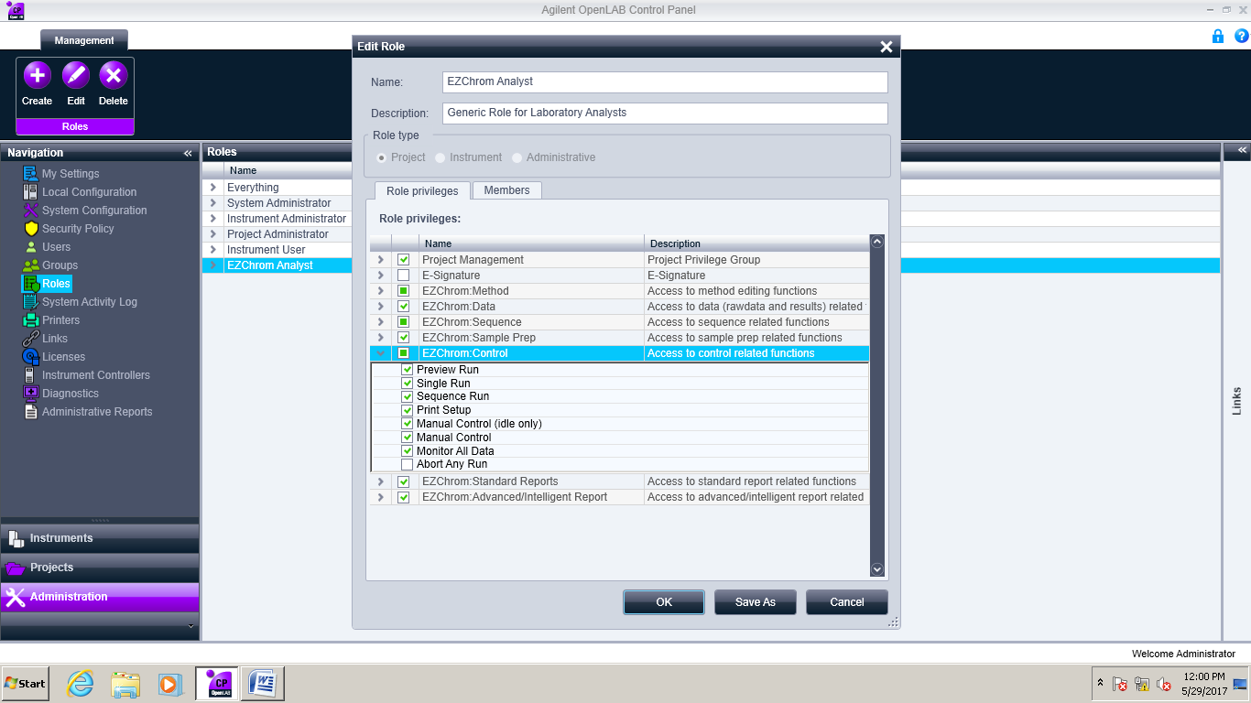

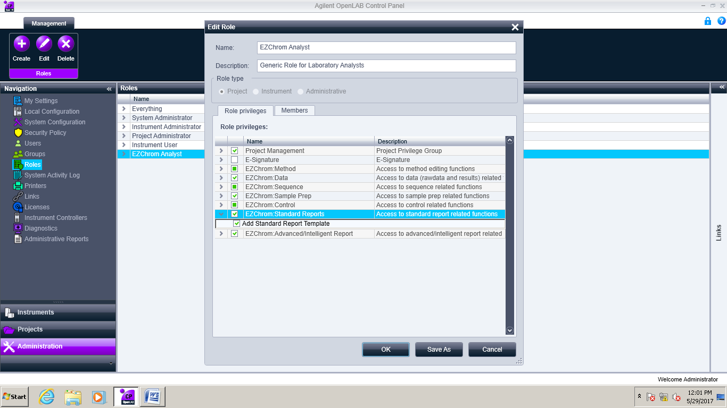

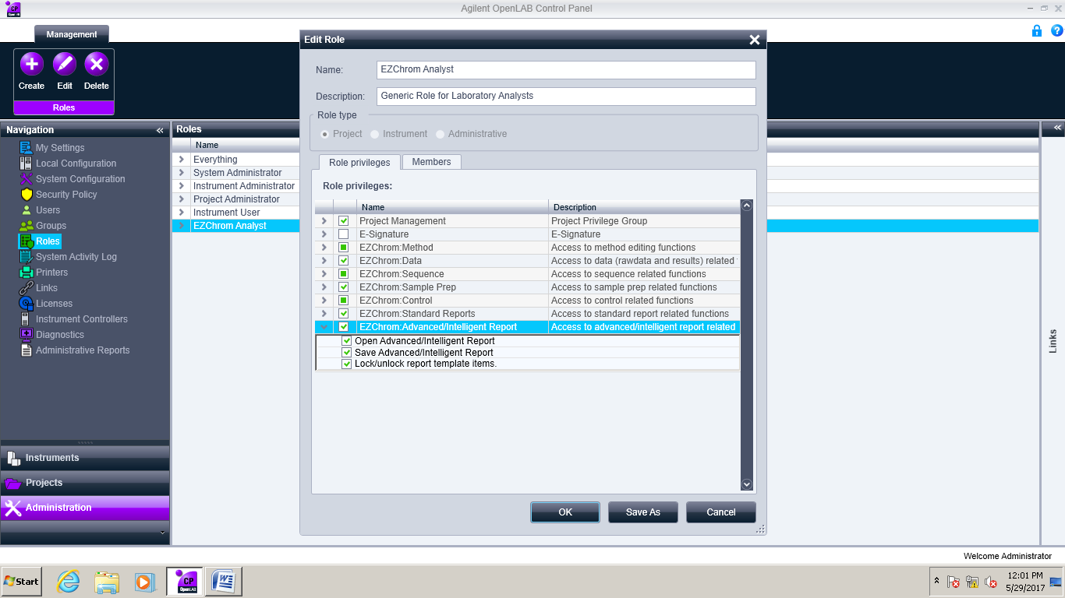

* 1. **Security policy:**
     1. Minimum password length : 6
     2. Password expiration period (days) : 90
     3. Maximum unsuccessful login attempts before locking account : 5
     4. Account lock time (minutes) : 10
     5. In activity time before locking the application (minutes) : 0
     6. Password shall preferably be alphanumerical (combination of alphabets and numbers).
     7. Each user at first time login shall change their password and should not be disclosed to others.
  2. **User ID creation:**
     1. User ID must be between 5 characters.
     2. User ID must be created with the employee ID Number along with “D” for QC personnel.

e.g..: DXXXX

Here:

“D” refers Discovery and “XXXX” refers Employee ID No.

* + 1. When received the Use ID requisition form QC to QA, the admin of software will create the user ID as per requisition.
    2. Allot the role membership as per user level.
    3. If existing chemist/Analyst will revise the job responsibilities then his/him allot role membership also will be revise.
    4. User ID for Administrator is admin/Admin.
    5. Software admin was QA

1. **FORMATS / ANNEXURE(S):**
   1. Instrument User ID requisition form : QC053-FM073
   2. List of Users : QC053-FM074
2. **CHANGE HISTORY:**

| **Revision No.** | **Effective Date** | **Details of Revision** | **Ref CCF No.** |
| --- | --- | --- | --- |
| 00 | 02.06.2017 | New SOP Introduced and separately prepared audit trail SOP, SOP No. SOP-QC-039-02 | CCF/GEN/  17015 |